**Question 1**

What is the optimal value of alpha for ridge and lasso regression? What will be the changes in the model if you choose double the value of alpha for both ridge and lasso? What will be the most important predictor variables after the change is implemented?

**ANSWER**:

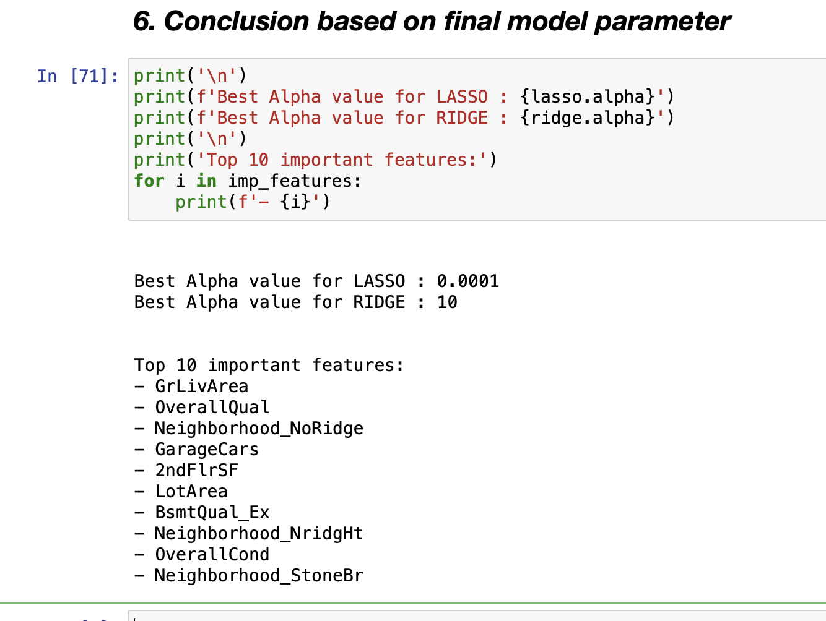

After doubling Alpha values in Ridge and Lasso, the R2 Score remains similar. However, there is change in intercepts.

**Question 2**

You have determined the optimal value of lambda for ridge and lasso regression during the assignment. Now, which one will you choose to apply and why?

ANSWER:

Lasso : As it helps in feature reduction as the coefficient value of some of the feature becomes zero.

Lasso has better edge over Ridge

**Question 3**

After building the model, you realised that the five most important predictor variables in the lasso model are not available in the incoming data. You will now have to create another model excluding the five most important predictor variables. Which are the five most important predictor variables now?

ANSWER:

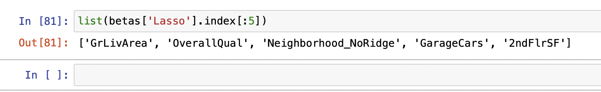

**Question 4**

How can you make sure that a model is robust and generalisable? What are the implications of the same for the accuracy of the model and why?

ANSWER:

Regularisation helps with managing model complexity by essentially shrinking the model coefficient estimates towards 0. This discourages the model from becoming too complex, thus avoiding the risk of overfitting.

In case of overfitting, we know that we need to manage the model’s complexity by primarily taking care of the magnitudes of the coefficients. The more extreme values of the coefficients are (high positive or negative values of the coefficients), the more complex the model is and, hence, the higher are the chances of overfitting

